AI-BASED RESUME SCREENING AND JOB MATCHING SYSTEM
A MINI PROJECT REPORT
Submitted by
SHETTY SAMIKSHA ANAND
USN: NN25MCA122
of
MASTER OF COMPUTER APPLICATIONS
NMAM Institute of Technology, Nitte

(An off-Campus Institution of Nitte (Deemed to be University), MANGALORE)
Nitte Mahalinga Adyanthaya Memorial Institute of Technology, Nitte
Department of MCA
November 2026
(An off-Campus Institution of Nitte (Deemed to be University), MANGALORE)
DEPARTMENT OF MCA
BONAFIDE CERTIFICATE
Certified that this project report "AI-BASED RESUME SCREENING AND JOB MATCHING SYSTEM" is the bonafide work of "SHETTY SAMIKSHA ANAND (USN: NN25MCA122)" who carried out the project work under my supervision.
SIGNATURE  (Project Guide) | SIGNATURE  (Head of the Department)
  Ms. Ashwini K M
  Assistant Professor Gd-I
  Department of MCA
  NMAM Institute of Technology, Nitte
  Nitte – 574 110, Karkala Taluk,
  Udupi District, Karnataka
  Dr. Mamatha Balipa
  Professor & Head
  Department of MCA
  NMAM Institute of Technology, Nitte
  Nitte – 574 110, Karkala Taluk,
  Udupi District, Karnataka
ABSTRACT
Deciding how well a resume fits a job description is a task that recruiters and job seekers repeat many times. Reading resumes by eye is slow and inconsistent, and a simple keyword filter misses resumes that describe the right experience in other words, for example "JS" instead of "JavaScript" or "built neural networks" instead of "deep learning". This project presents a local web application that compares a text-based PDF resume with a job description and explains the result.
The application is written in Python and runs with Streamlit. It reads the text of the PDF files with pypdf and reports three scores: a text similarity score from TF-IDF cosine similarity, a skill match score from a skill dictionary with synonyms covering technology, marketing, HR, finance, design and soft skills, and an optional meaning similarity score from the all-MiniLM-L6-v2 model, which runs on the same computer after a one-time download of about 90 MB. The scores are summarised as an overall match level (Strong, Partial or Weak) with the reasons and a suggested next step. The application also shows a chart of matched and missing skills, the resume and the job description side by side with the skills highlighted, ranked rule-based suggestions for improving the resume, an optional improved resume draft that adds a skill only if the user confirms it, and a downloadable text report.
The application does not use a database and does not save the uploaded resumes, and the suggestions are produced by local rules, so no external AI service sees the resume. The scores measure how similar two texts are; they are not a hiring probability and are meant to assist, not replace, human review. The main limitations are that scanned PDFs are not supported, that two-column resumes can merge their columns, and that skill detection depends on the words in the dictionary. Support for scanned documents, a larger dictionary and the ranking of several resumes against one job are planned as future work.
TABLE OF CONTENTS
CHAPTER NO. TITLE PAGE NO.
ABSTRACT iii
TABLE OF CONTENTS iv
1. INTRODUCTION 1
1.1 Problem Definition 1
1.2 Objectives 1
1.3 Challenges 1
1.4 Literature Survey 2
2. SOFTWARE REQUIREMENT SPECIFICATION 3
2.1 Functional Requirements 3
2.2 Non-functional Requirements 3
2.3 Hardware and Software Requirements 3
3. SYSTEM DESIGN 5
3.1 High Level Design 5
3.2 Detailed Design 6
4. SYSTEM IMPLEMENTATION 8
4.1 Module Description 8
4.2 Tools, Language and RDBMS used 8
4.3 Screen Shots 9
5. TESTING 10
5.1 Test Approach 10
5.2 Test Cases 10
5.3 Expected Behaviour on Example Inputs 10
5.4 Limitations Identified 11
6. CONCLUSION AND FUTURE ENHANCEMENTS 12
REFERENCES 13

CHAPTER 1
INTRODUCTION
Every job opening brings many resumes, and someone must decide which of them fit the job description. Reading them by eye is slow, and the judgement differs from one reader to another. A resume may also describe the right experience in different words from the advertisement, so a simple keyword search can miss it, and a job seeker who is rejected rarely learns the reason. Text-matching methods can assist by measuring how close a resume is to a job description and by showing which skills are present or missing. This project builds such a system as a local web application and, importantly, explains every score so that the user can check it.
1.1 Problem Definition
A recruiter or a job seeker must compare a resume with a job description manually, which is slow, inconsistent and easily affected by wording. The problem is to design and implement a software system that accepts a text-based PDF resume and a job description, calculates how well they match using more than one method, shows which skills of the job are found in the resume and which are not detected, gives an overall match level with reasons, suggests how the resume can be improved for the job, and does this on the user's own computer without saving the resume or sending it to an outside AI service.
1.2 Objectives
- Read the text of a PDF resume and of a job description (pasted text or PDF) and clean it for comparison.
- Calculate three scores: text similarity with TF-IDF cosine similarity, skill match with a skill dictionary and synonyms, and an optional meaning similarity with the all-MiniLM-L6-v2 model.
- Give an overall match level (Strong, Partial or Weak) with the reasons and a suggested next step, worded as a match to the job and not as a judgement of the person.
- Show matched skills and skills not detected, a chart by category, the top shared keywords and a side-by-side view with the skills highlighted.
- Give ranked, job-specific, rule-based suggestions, and an optional improved resume draft in which a skill is added only if the user confirms it.
- Keep the processing local, save no resume, and provide unit tests and sample data.
1.3 Challenges
- Reading PDFs: a scanned PDF contains no text, and a two-column layout can be extracted with its columns merged.
- Different wording: the same skill can be written as an abbreviation or a synonym, such as JS, K8s or NLP, so exact matching is not enough.
- Lexical against meaning: TF-IDF compares words and cannot know that "built neural networks" relates to "deep learning"; a meaning-based model is needed for this.
- Explainability: a single unexplained number is of little use, so each score has to be shown with the skills and the reasons behind it.
- Privacy and hardware: resumes are personal, so the processing is kept local, and the AI model needs about 650 MB of memory when loaded.
- Responsible use: the scores are similarity measures, not hiring probabilities, and the advice must not push the user to claim skills that are not true.
1.4 Literature Survey
Matching a resume to a job is commonly treated as an information retrieval problem, in which the job description is the query and the resume is the document to be scored. A classic method is TF-IDF, in which each word receives a weight that grows with its frequency in a text and falls when the word is common everywhere (Salton and Buckley, 1988). Each text becomes a vector of weights, and cosine similarity measures the angle between two vectors. The method is fast and easy to explain, but it is lexical and does not understand meaning.
Sentence embedding models convert a text into a vector so that texts with a similar meaning lie close together even when they share few words (Reimers and Gurevych, 2019). The all-MiniLM-L6-v2 model used in this project belongs to the MiniLM family of small models (Wang et al., 2020) and can run on an ordinary processor, so the comparison can be made on the user's own computer.
Skills can be found by matching a text against a curated dictionary. This needs no training data and the result can be shown to the user, but it finds only the words in the list, so abbreviations and synonyms must be added by hand. The project combines a categorised skill dictionary with a synonym table.
Open-source tools make such a system practical: PyTorch (Paszke et al., 2019) for running the embedding model, Streamlit for the web interface, pypdf for reading PDF text, Plotly for the gauges and charts, and pytest for the unit tests. This project combines them into one application and states its weaknesses openly.
CHAPTER 2
SOFTWARE REQUIREMENT SPECIFICATION
2.1 Functional Requirements
Table 2.1: Functional requirements
ID | Requirement
FR1 | Accept a text-based PDF resume uploaded through the web interface (upload limit 5 MB).
FR2 | Accept the job description as pasted text or as a PDF, with at least 15 words.
FR3 | Extract and clean the text of both documents; warn when a two-column resume has merged columns.
FR4 | Extract the skills of the job and of the resume using the skill dictionary and synonyms.
FR5 | Calculate the text similarity (TF-IDF cosine similarity) and the skill match.
FR6 | Calculate the meaning similarity with the local AI model when it is available and selected.
FR7 | Show an overall match level (Strong, Partial or Weak) with reasons and a suggested next step.
FR8 | Show matched skills and skills not detected, a chart by category, the top shared keywords and the two texts side by side with highlighting.
FR9 | Give ranked, job-specific suggestions for improving the resume.
FR10 | Build an optional improved resume draft, adding a missing job skill only if the user ticks it, and allow download as PDF or text.
FR11 | Provide a downloadable text report with the scores, skills and suggestions.
2.2 Non-functional Requirements
Table 2.2: Non-functional requirements
Attribute | Requirement
Performance | One resume and one job description are small texts and are analysed on an ordinary computer; the AI model needs a one-time download and about 650 MB of memory when loaded.
Usability | Simple web interface: upload the resume, give the job description and click Analyze Resume.
Consistency | The skill dictionary is shared by the skill score, the chart, the highlighting and the suggestions, so the results agree.
Privacy | The text is processed on the computer, no resume is saved, the suggestions are rule-based, and the AI model runs offline after it is downloaded.
Maintainability | One module for each task in the src folder; thresholds in verdict.py; skills and synonyms in two lists that the user can edit.
Honesty of results | Scores are described as similarity, not as a hiring probability, and suggestions are prompts to check, not instructions.
Portability | Set-up commands are given for Windows, macOS and Linux, and the application can be hosted on Streamlit Community Cloud.
2.3 Hardware and Software Requirements
Table 2.3: Hardware requirements
Component | Specification
Processor | Any modern processor; no GPU is needed because the CPU-only build of PyTorch is used.
RAM | At least 1 GB free; the project documentation reports about 650 MB with the AI model loaded.
Storage | Free space for the Python environment, the packages and the AI model of about 90 MB.
Network | Internet connection once, to install the packages and to download the model.
Display / Input | Standard monitor, keyboard and mouse; web browser for running the application.
Table 2.4: Software requirements
Component | Specification
Operating system | Windows (commands documented); macOS or Linux with the equivalent commands.
Language | Python 3 with pip and virtual environments.
Libraries | Streamlit, pypdf, Plotly, TF-IDF similarity code, sentence-transformers with CPU-only PyTorch (optional), pytest; all listed in requirements.txt.
Tools and browser | Command Prompt or terminal, Visual Studio Code or any editor, Git, and any modern web browser.
CHAPTER 3
SYSTEM DESIGN
3.1 High Level Design
The system is a single-process application (Figure 3.1). The user works in a Streamlit page served by app.py, which validates the inputs and passes them to the modules of the src folder. The text of the resume and of the job description is extracted with pypdf and cleaned. The skills are extracted with the dictionary and synonyms, and the text similarity is calculated with TF-IDF and cosine similarity. If the user selects it and the package is installed, the meaning similarity is calculated with the all-MiniLM-L6-v2 model. The scores and skills are summarised as an overall match level, and the suggestions, highlighting and charts are produced. No database and no external service are required, and no resume is saved.
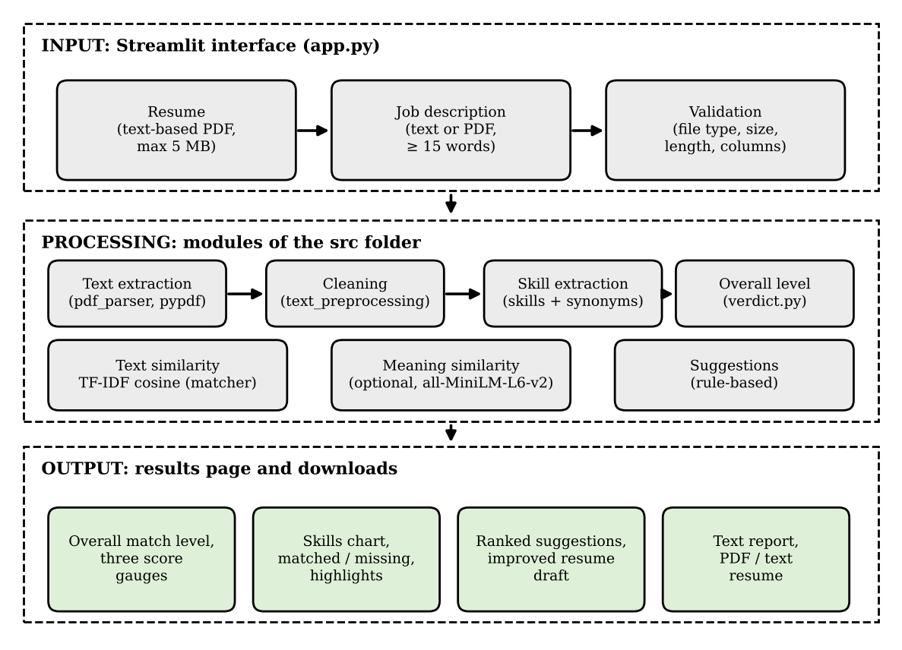
Figure 3.1: High-level architecture of the Resume Screening and Job Matching system
The inputs and outputs of the system are summarised in Table 3.1.
Table 3.1: Inputs and outputs of the system
Kind | Item | Description
Input | Resume | Text-based PDF file, up to 5 MB.
Input | Job description | Pasted text or a text-based PDF, at least 15 words.
Input | Options | Switch for the meaning similarity; skills ticked by the user for the improved resume.
Output | Scores and level | Text similarity, skill match, optional meaning similarity, and the overall level with reasons.
Output | Skill views | Matched and not detected skills, chart by category, top shared keywords, side-by-side highlighting.
Output | Advice and files | Ranked suggestions, improved resume draft (PDF or text) and the text report.
3.2 Detailed Design
3.2.1 Scoring model design
Three scores are calculated and each is shown as a gauge. The text similarity is the cosine similarity of the TF-IDF vectors A and B of the two texts, (A . B) / (|A| x |B|), and measures word overlap. The skill match is the number of job skills found in the resume divided by the number of skills found in the job description, multiplied by 100. The meaning similarity is the similarity of the embeddings produced by the all-MiniLM-L6-v2 model, so that "built neural networks" can match "deep learning". The three scores look at the texts in different ways and are therefore shown separately. Before the comparison, the text of both documents is cleaned by one preprocessing module.
Table 3.2: Configuration of the scoring components
Parameter | Value
Text similarity | TF-IDF cosine similarity (matcher.py)
Skill match | Share of the job's skills found in the resume (skill_extractor.py)
Meaning similarity | Local all-MiniLM-L6-v2 model, about 90 MB, optional (semantic_matcher.py)
Skill categories | Technology, marketing, HR, finance, design, soft skills (SKILL_CATEGORIES)
Synonym examples | JS = JavaScript, K8s = Kubernetes, NLP = natural language processing (SYNONYMS)
Overall levels | Strong, Partial, Weak; thresholds in verdict.py
Minimum job description | 15 words
Upload limit | 5 MB (.streamlit/config.toml)
3.2.2 Data design
No relational database is used. The skill dictionary and the synonym table are stored as lists in skill_extractor.py, the match thresholds in verdict.py, and the Streamlit settings, including the upload limit, in .streamlit/config.toml. Uploaded resumes are processed in memory and are not saved. The report and the improved resume are generated when the user asks for them and are downloaded as a text file or a PDF. Sample resumes, job descriptions and invalid files for trying the system are kept in the folder sample_data.
3.2.3 Application flow
Figure 3.2 shows the processing flow. The user opens the web page, uploads a resume, gives the job description and clicks Analyze Resume. The application checks that the resume is a text-based PDF, that the job description has at least 15 words and that the files are within the size limit; otherwise a message is shown. The text is then extracted and cleaned, the skills and scores are calculated, and the result page shows the overall level, the gauges, the skills, the highlighted texts and the suggestions. If the user wants a tailored resume, the improved resume draft is built after the user ticks the job skills that he or she really has. If two columns of a resume appear merged, a warning is shown and the advice about sections is skipped.
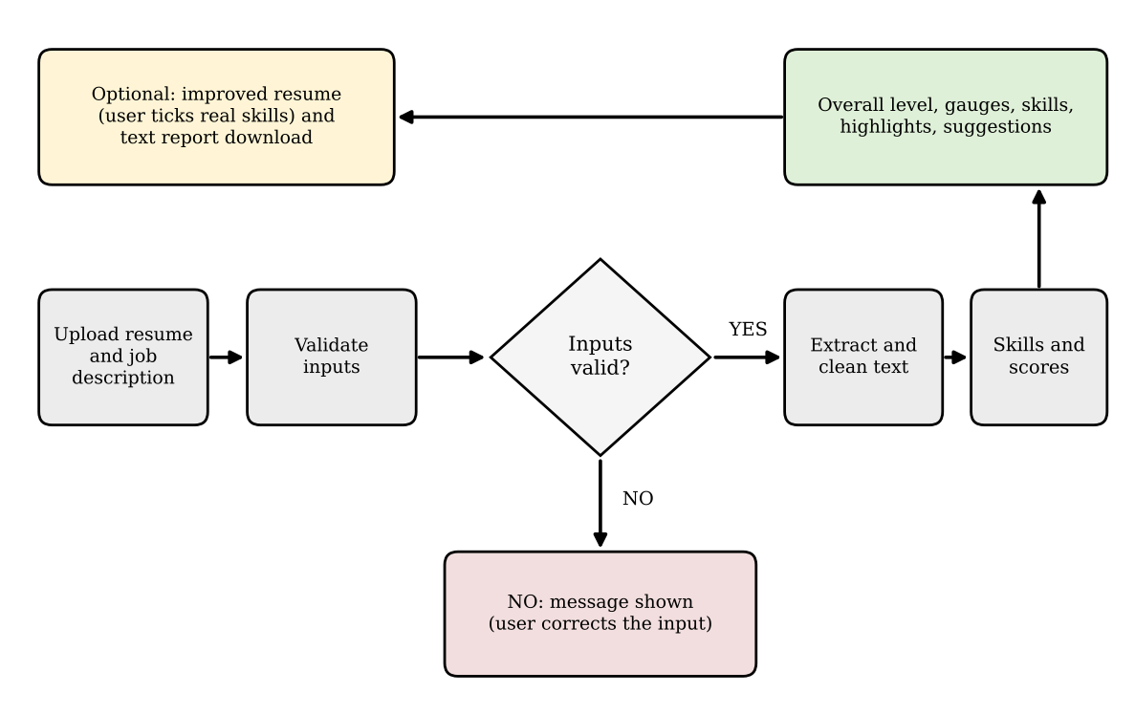
Figure 3.2: Flowchart of the analysis process in the application
CHAPTER 4
SYSTEM IMPLEMENTATION
4.1 Module Description
Module 1: Interface and validation (app.py)
The Streamlit page with the upload box for the resume, the text box or upload for the job description, the option for the meaning similarity and the Analyze Resume button. It validates the inputs and shows the results, the improved resume option and the download buttons.
Module 2: Input processing (pdf_parser.py, text_preprocessing.py)
Extracts the text of the PDF files with pypdf and cleans it for comparison. Scanned PDFs contain no text and are not supported.
Module 3: Skill extraction (skill_extractor.py)
Holds the skill dictionary in categories and the synonym table, and finds the skills of the job and of the resume. The same dictionary is used for the chart, the highlighting and the suggestions.
Module 4: Similarity (matcher.py, semantic_matcher.py)
matcher.py calculates the TF-IDF cosine similarity. semantic_matcher.py calculates the meaning similarity with the all-MiniLM-L6-v2 model; it is optional and is disabled when sentence-transformers is not installed.
Module 5: Overall level and suggestions (verdict.py, suggestions.py)
verdict.py turns the scores and skills into Strong, Partial or Weak with reasons and a next step. suggestions.py produces ranked, rule-based suggestions that use the job's own wording to separate required from optional skills.
Module 6: Presentation (highlighter.py, charts.py)
Marks the matched and not detected skills in the two texts, including synonyms, and draws the gauges, the skills chart and the top shared keywords chart with Plotly.
Module 7: Resume builder and report (resume_builder.py, report_generator.py)
resume_builder.py builds the improved resume draft and its one-column PDF; report_generator.py creates the plain-text report.
Module 8: Self-test (tests/, sample_data/)
pytest unit tests for the modules, run with python -m pytest, and sample resumes, job descriptions and invalid files.
4.2 Tools, Language and RDBMS used
Table 4.1: Tools and technologies
Category | Tool / Technology
Programming language | Python 3
Application framework | Streamlit
PDF reading | pypdf
Text similarity | TF-IDF and cosine similarity
Meaning similarity | sentence-transformers, all-MiniLM-L6-v2, CPU-only PyTorch
Charts | Plotly
Testing | pytest
Hosting (optional) | Streamlit Community Cloud
RDBMS | None used. Data is kept in code lists, settings files and sample files.
4.3 Screen Shots
The screens of the application are shown in Figures 4.1 to 4.3.
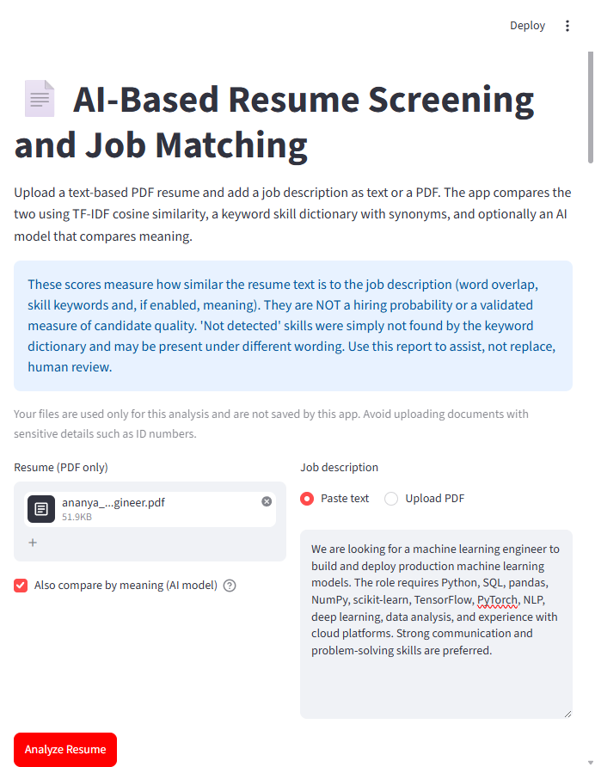
Figure 4.1: Resume Screening Interface
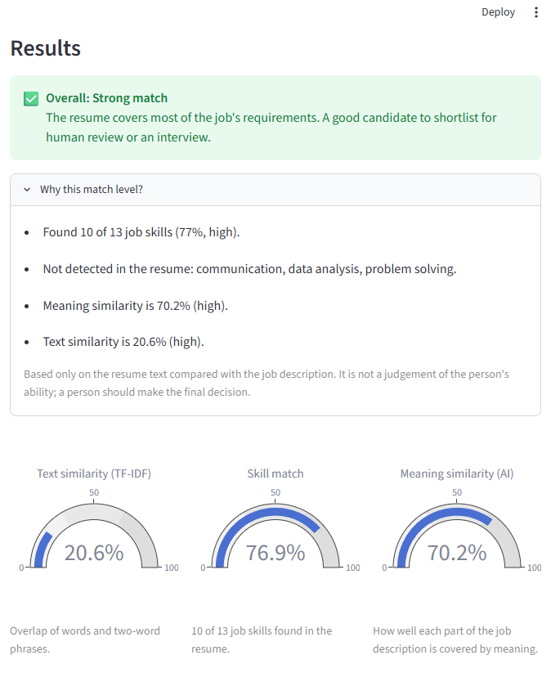
Figure 4.2: Overall Match Level and Score Gauges
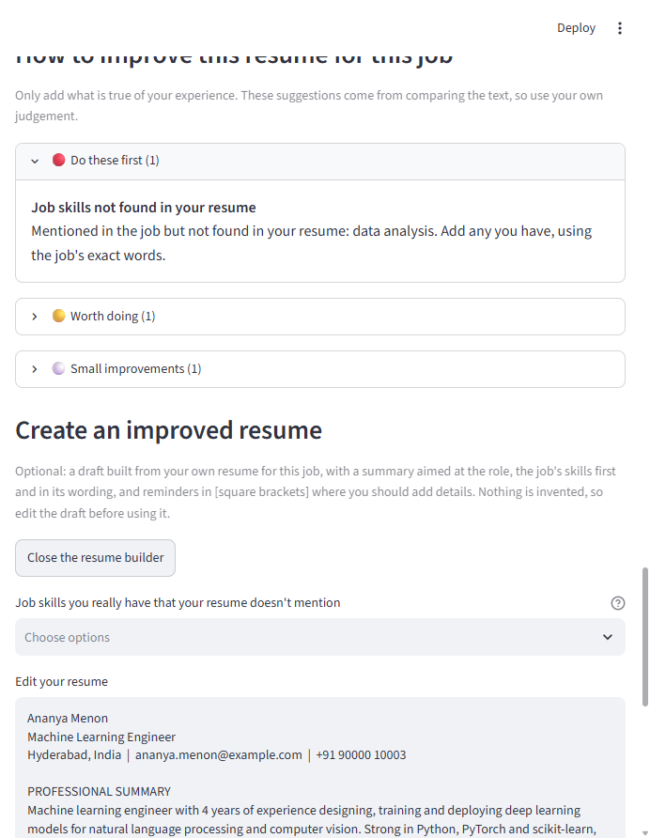
Figure 4.3: Improvement Suggestions and Improved Resume Builder
CHAPTER 5
TESTING
5.1 Test Approach
Testing is planned on three levels: unit tests of the modules with pytest, trials of the application with the sample resumes and job descriptions of the folder sample_data, and trials with the invalid files of the same folder to check the validation. The test cases below are derived from the behaviour described in the project documentation. They were not run while this report was prepared, so the status column is to be completed after running the application.
5.2 Test Cases
Table 5.1: Test cases
ID | Test description | Expected result | Status
T1 | Install the packages and start the application with streamlit run app.py | Page opens in the browser, usually at http://localhost:8501 | Passed
T2 | Run python -m pytest | The unit tests of the tests folder run and report their result | Passed (262 tests)
T3 | Upload a text-based PDF resume and a job description of at least 15 words | Overall level, three scores, skills, highlighting and suggestions are shown | Passed
T4 | Give a job description shorter than 15 words | The analysis is not run and a message asks for a longer description | Passed
T5 | Upload a scanned or image-only PDF | The file is not supported because it has no text | Passed
T6 | Upload a file larger than 5 MB | The upload is refused by the size limit | Passed
T7 | Resume contains "JS", job contains "JavaScript" | The skill is counted as matched through the synonym table | Passed
T8 | Resume says "built neural networks", job says "deep learning", meaning similarity on | The meaning similarity reflects the relation that word overlap misses | Passed
T9 | Run without sentence-transformers installed | The meaning similarity checkbox is disabled; two scores are shown | Passed (AI enabled; semantic comparison returned 45.7%)
T10 | Upload a two-column resume whose columns merge | A warning is shown and the advice about sections is skipped | Passed
T11 | Create the improved resume with and without ticking a missing skill | The skill is added only when it is ticked | Passed
T12 | Download the text report | The file contains the scores, skills and suggestions | Passed
5.3 Expected Behaviour on Example Inputs
As an illustration of the skill score, if a job description names 10 skills of the dictionary and 6 of them are found in the resume, directly or through synonyms, the skill match is 6 / 10 x 100 = 60%. A resume that uses the right skills in other words would therefore show a good skill match but a lower text similarity, which is why the scores are shown separately. If no meaningful text can be read from the resume, the analysis cannot be done, and the user is told that a text-based PDF is needed.
5.4 Limitations Identified
The following limitations are stated in the project documentation or follow from it.
- No OCR: scanned and image-only PDFs are not supported, for resumes and for job descriptions.
- Rule-based suggestions: they can miss things or misread a resume, and are prompts to check, not instructions.
- Two-column PDFs: the columns may be merged; the application warns and skips the advice about sections but does not rebuild the columns.
- Improved resume: the draft reuses the user's text and only rearranges and adds to it; it does not rewrite the sentences.
- Dictionary dependence: only words of the dictionary are found, and a synonym that is not in the table may be missed.
- Similarity, not judgement: TF-IDF does not understand meaning, and even the AI score is a similarity measure and not a judgement of the candidate.
- Hosting: the online copy has no login and uploaded resumes leave the user's computer; the memory of about 650 MB with the model loaded should be considered when a host is chosen.
- Scope: one resume is compared with one job description at a time.
The application is a student project to assist a reader and is not a tool for taking hiring decisions on its own.
CHAPTER 6
CONCLUSION AND FUTURE ENHANCEMENTS
The project built a system that compares a PDF resume with a job description using TF-IDF cosine similarity, a skill dictionary with synonyms and an optional local AI model, and that explains the result. The application gives an overall match level with reasons, shows which skills are matched and which are not detected, suggests how the resume can be improved for the job, and can build an improved resume draft in which a skill is added only if the user confirms it. The processing is local, no resume is saved, and the suggestions come from rules, so no outside AI service sees the resume. Stating the limits of the scores openly, as similarity measures and not hiring probabilities, is a main outcome of the work.
Future Enhancements
- OCR for scanned files: read scanned and image-only PDFs so that more resumes can be analysed.
- Better two-column reading: rebuild the columns of a two-column resume instead of only warning about them.
- Larger configurable dictionary: add more fields and synonyms, and let the user load their own skill list.
- Ranking of several resumes: compare many resumes with one job description and list them in order.
- More file formats: accept Word documents as well as PDF files.
- Access control: add a login to the hosted version so that not everyone with the link can use it.
- Evaluation: compare the scores with resumes judged by recruiters to check how well they agree.
- Extra feature for the major project: one additional feature such as a score history for several job descriptions or a downloadable PDF report.
REFERENCES
1. Salton, G. and Buckley, C. (1988) 'Term-weighting approaches in automatic text retrieval', Information Processing & Management, Vol. 24, No. 5, pp. 513–523.
2. Reimers, N. and Gurevych, I. (2019) 'Sentence-BERT: Sentence Embeddings using Siamese BERT-Networks', Proc. EMNLP-IJCNLP, pp. 3982–3992.
3. Wang, W. et al. (2020) 'MiniLM: Deep Self-Attention Distillation for Task-Agnostic Compression of Pre-Trained Transformers', Advances in Neural Information Processing Systems, Vol. 33.
4. Paszke, A. et al. (2019) 'PyTorch: An Imperative Style, High-Performance Deep Learning Library', Advances in Neural Information Processing Systems, Vol. 32.
5. Streamlit Inc., 'Streamlit Documentation', https://docs.streamlit.io
6. pypdf Developers, 'pypdf Documentation', https://pypdf.readthedocs.io
7. SBERT.net, 'Sentence-Transformers Documentation', https://www.sbert.net
8. Plotly, 'Plotly Python Graphing Library', https://plotly.com/python/
9. pytest Developers, 'pytest Documentation', https://docs.pytest.org
10. Shetty, S. A., 'AI-Based Resume Screening and Job Matching System', GitHub repository, https://github.com/samikshashetty29/ai-resume-screening

